**Region 34 Coaches Meeting 5U to 8U**

August 28, 2025

Thank you for coaching!

**Important Resources:**

* [Coaches Corner](https://www.ayso34.org/Default.aspx?tabid=857191)
* [Region 34 Contacts](https://www.ayso34.org/Default.aspx?tabid=857209)
* [Incident Report](https://dt5602vnjxv0c.cloudfront.net/portals/14693/docs/forms/ayso%20incident%20report%20form%20with%20instructions%202019.pdf)
* [Game Card Instructions](https://www.ayso34.org/Default.aspx?tabid=964228)
* [Coach Certification Step-by-step](https://dt5602vnjxv0c.cloudfront.net/portals/14693/docs/for%20parents/2022_how%20to%20volunteer%20%20find%20coach%20courses.v002.pdf)
* [Equipment Storage Procedures](https://www.ayso34.org/Default.aspx?tabid=971110)
* [Julia & Alta Vista Equipment Storage Map](https://dt5602vnjxv0c.cloudfront.net/portals/14693/docs/fields/2023_avp%20storage%20area.pdf)
* [Field Setup Diagrams](https://www.ayso34.org/Default.aspx?tabid=857192)
* [Practice Field Diagram](https://dt5602vnjxv0c.cloudfront.net/portals/14693/docs/misc%20coach%20and%20ref%20docs/practice%20field%20diagram.pdf)

**AYSO Philosophies**

1. Everyone Plays
2. Balanced Teams
3. Open Registration
4. Positive Coaching
5. Good Sportsmanship
6. Player Development

**Be him:** **NOT him:**

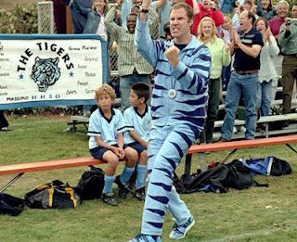

* **Region 34 Contacts**
  + Coach Administrator (5U-8U)
    - Suren Sagadevan / [suren7276@gmail.com](mailto:suren7276@gmail.com) / 310-386-0302
  + Division Coordinators – your first points of contact for anything
    - GU5/BU5 Igor Brin / [igor.brin@yahoo.com](mailto:igor.brin@yahoo.com)
    - GU6 Miriam Arato / [miriam459@yahoo.com](mailto:miriam459@yahoo.com)
    - BU6 Suren Sagadevan / [suren7276@gmail.com](mailto:suren7276@gmail.com)
    - GU7 Scott Witter / [switter@breakwateradvisers.com](mailto:switter@breakwateradvisers.com)
    - BU7 Brian Casey / [BrianCaseyBTC@YAHOO.COM](mailto:BrianCaseyBTC@YAHOO.COM)
    - GU8 Josh Rosen / [jrosen122@gmail.com](mailto:jrosen122@gmail.com)
    - BU8 Tom Riester / [tomriester.ayso34@gmail.com](mailto:tomriester.ayso34@gmail.com)
* **Coach Certification & Training**
  + MUST complete or you will not receive Coach Badge (only coaches with badges are allowed to be in the box)
* ***Coaching Evaluations***
  + *You will not receive yearbooks or medals without completing and submitting*
* **Schedules & Fields**
  + Practice Schedule
  + [Field Layout](https://drive.google.com/file/d/0B7GlKNY-2Mz5QS13QWxDTUZ5QVU/view)
* **Player Forms** 
  + Have printed out player forms with you for all AYSO sponsored activities (practices, games, events, etc.)
  + The player registration forms give you the legal authority to seek medical attention in the event one of your players is injured during a practice or game
  + Keep the forms with you at ALL AYSO activities
  + You are only legally covered for players that are on your team roster
  + Practicing with another team is fine, just make sure the other coach is present with their teams’ forms
  + Only players listed on your roster can play in your games
* **Policies**
  + Players with casts or splints may NOT play in games or practices even if the cast is padded and the player has been cleared by a doctor.
  + Earrings, piercings, jewelry (bracelets), etc., must be removed before the player can take the field.
* **Game Day Procedures – Set up and Take down**
  + Teams having the first game of the day (on each field) are responsible for set up – this includes painting lines, setting up of goals, placing flags in proper locations.
  + Storage bags get put away after setup. Please do not leave on the field.
  + Teams having the last game on of the day are responsible for putting everything away in the proper locations.
  + Teams are responsible for making sure no trash is left behind after games – please have parents and players contribute to clean up effort
  + No pets allowed on fields at any time.
  + *Lining the fields*
* ***Post-Game Etiquette***
  + *Parents to pack up and move from the spectator area on the sidelines immediately after the game (so we can stay on schedule for the day)*
  + *Clean up sidelines prior to leaving*
* **Conduct**
  + Players Play
  + Coaches Coach
    - Positive Coaching
    - Only positive words of encouragement during practices and games
  + Parents Cheer
  + Behavior towards Referees
    - No comments should be made to the referees
    - ZERO tolerance policy for poor treatment of youth referees
    - How to address issues with officiating
  + Avoiding blowouts!
    - This is a recreational league so do what’s within your power as a coach to avoid lopsided scores. If a situation is building, consider the following options.
      * Awareness of the situation (for example, a 3 or 4 goal lead before halftime)
      * Avoid instructing your players to “go easy” on the other team. Instead, use this as an opportunity to work on other aspects of the game like passing.
      * Encourage passing, but be specific (5 passes before you can shoot, everyone must touch the ball before you can shoot, etc.)
      * Offer to loan players to the other team (especially if the game starts out with a mismatch with the number of players)
      * Move players around to different positions (this doesn’t always resolve the issue because good scorers are often good defenders)
* **Safety** 
  + If a player or volunteer is injured during an AYSO sponsored activity (practice, game or other team activity), the coach must fill out the Incident [Report Form](https://dt5602vnjxv0c.cloudfront.net/portals/14693/docs/forms/ayso%20incident%20report%20form%20with%20instructions%202019.pdf) (found on the Region 34 website)
  + Must do it ASAP (within 24 hours)
  + If the referee sends a player off the field because they suspect a concussion, the player is NOT to return to the field that day.
* **Team Management**
  + Blue Sombrero is the system we use
  + Once we “Post Roster” you can use the features to manage your team (or use other apps like TeamSnap)

**U7 and U8 Division Specific Items**

* **Guidelines**

|  |  |  |  |  |  |  |
| --- | --- | --- | --- | --- | --- | --- |
| **Division** | **Ball Size** | **# of players** | **Time** | **Keep Score?** | **Fouls** | **Goalies** |
| U7 | 3 | 7 v 7 | 4 x 10 min | ** | Indirect Free Kick | No |
| U8 | 3 | 7 v 7 | 4 x 10 min | ** | Indirect Free Kick | Yes |

*\*\*Referee keeps score for region records and statistical purposes only. No official scores or won/loss records are kept. There are no playoffs for U8 and below*

* Referees and Parent Linesman
  + Each team is expected to provide a linesmen for each game
  + You will be provided a vest and flag to give your parent
  + The linesman is there to assist the ref to call ball out of play and indicate the direction of throw-in
* Important Guidelines for U7/8
  + Coach Technical Area – remain in the designated technical area during the game
    - Also, instruct parents they should remain in the designated area for spectators (for example, avoid standing near the corner flag to instruct their player who may be playing keeper)
  + Offside
    - NO Offside rule but stick to the spirit of the game
  + Build-out lines (BOL)
    - The BOL will be approximately equidistant from the top of the penalty area and the halfway line and will be used in U8 and U10 divisions.
    - When the keeper gains possession of the ball or at goal kicks, all opposing players must move behind the BOL. Opposing players can cross the BOL once the keeper releases the ball from his or her hands or once the ball is kicked from a goal kick.
    - A keeper does not have to wait for all opposing players to be behind the BOL before releasing the ball.
    - If an opposing player crosses the BOL before a keeper releases it, the referee may choose to halt play and restart with a drop ball to the keeper. If an opposing player crosses the BOL before the ball is kicked from a goal kick, the referee may choose to halt play and have the goal kick retaken.

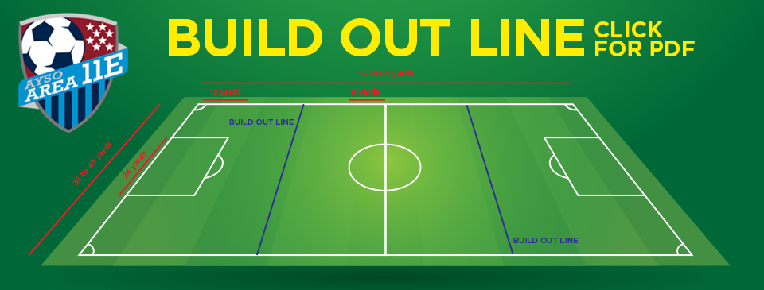

* + Notable Laws of the Game for these age groups
    - Goal Kicks – live once ball is kicked or noticeably moves (does NOT have to leave the penalty area
    - Drop Balls – only ONE player for drop balls, not two (player from team that last touched the ball)
  + Throw ins / Kick ins
    - U7 kick ins
    - U8 throw ins
* Goalie (U8)
  + No punting or drop-kicking by the keeper
  + A punt/drop-kick is considered dropping the ball from a hand and kicking it before or as it hits the ground
  + A keeper may play the ball to his or her own feet and may dribble or pass.
  + Violations will result in an IFK at the spot of the foul.
  + A keeper who attempts to circumvent this rule by disguising a punt/drop-kick as a pass may be called for a violation at the discretion of the referee.
* Game Cards (U7/8)
  + Walk through completing a game card (U7/8)

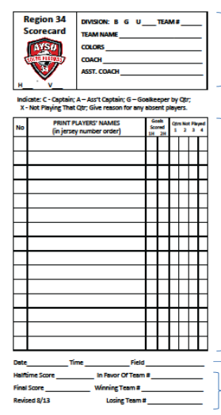

**U5 & U6 Specific Items**

* **Guidelines**

|  |  |  |  |  |  |  |
| --- | --- | --- | --- | --- | --- | --- |
| **Division** | **Ball Size** | **# of players** | **Time** | **Keep Score?** | **Fouls** | **Goalies** |
| U5 | 3 | 3 v 3 | 4 x 5 min | No | None – drop ball only | No |
| U6 | 3 | 4 v 4 | 4 x 7 min | No | None – drop ball only | No |

*\*\*Referee keeps score for region records and statistical purposes only. No official scores or won/loss records are kept. There are no playoffs for U8 and below*

* U5 Jamboree
  + Discuss format (training session and game)
  + NO weekday practices
* U5/6 Guidelines
  + Kick ins (no throw ins)
  + No heading the ball
  + No goalkeepers. Please do NOT have defender stay back and wait in front of or near goal when ball is on opposing side. Get the kids involved in the game.
  + No offside rule
  + Home team provides ball. Visiting takes first-half kickoff and chooses direction.
  + After the first two periods, teams switch sides; home team kicks-off to start second half.
  + Once the ball is clearly out of the playing area, all regular, appropriate re-starts shall be utilized: goal kick, corner kick, kick-in.
  + After a goal is scored, the opposing team takes a kick-off.
  + Remind players to pass to teammate on re-start; players should not be playing the ball to themselves.
  + A goal may not be scored directly from a kick-in.
  + There are no fouls called in U5 / U6 soccer. If a foul occurs (use of hands, obvious pushing, etc.), the coach should gently remind players of the rules and re-start play with a drop ball.
  + The only adults allowed on the field are one coach from each team.
  + Players are substituted at the quarter, or in the event of illness or injury. However, if a player does not want to continue, or needs an additional break, flexibility in substitution is allowed. Substitution rule: No player can play 4 quarters until all players play at least 3 quarters.
  + At each quarter (5 min for U5 and 7 min for U6), take a quick water break and make substitutions. This is not time for additional coaching or practicing. The break should take about 30 seconds. It is important to keep the games moving.